Calculator

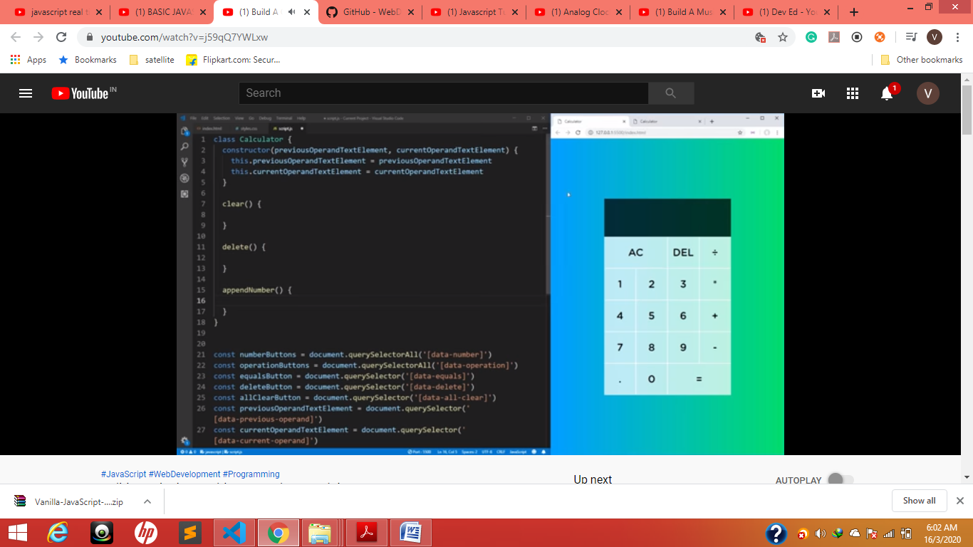

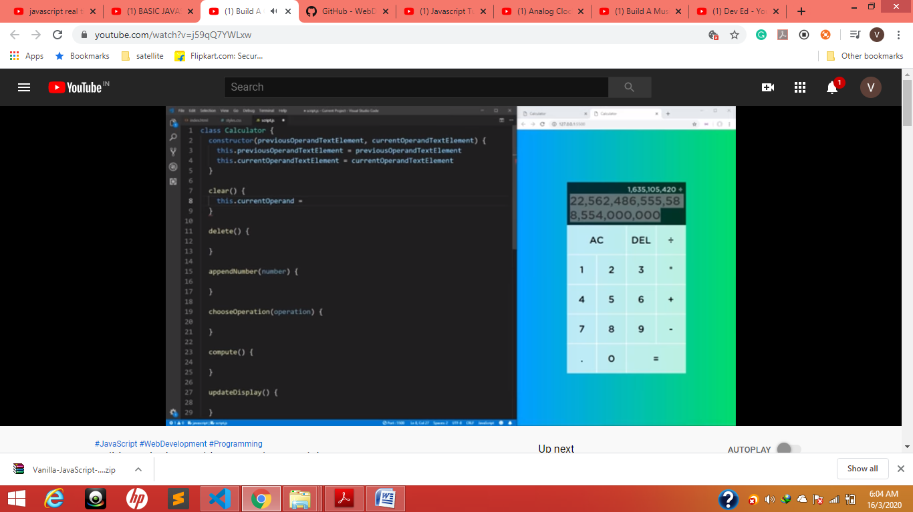

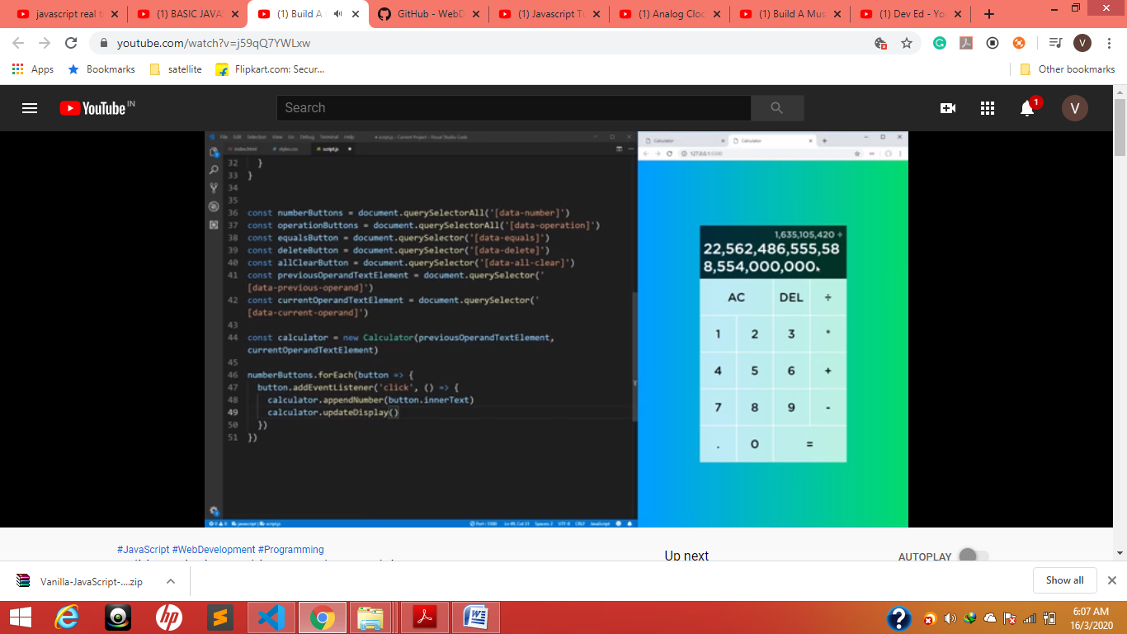

48line

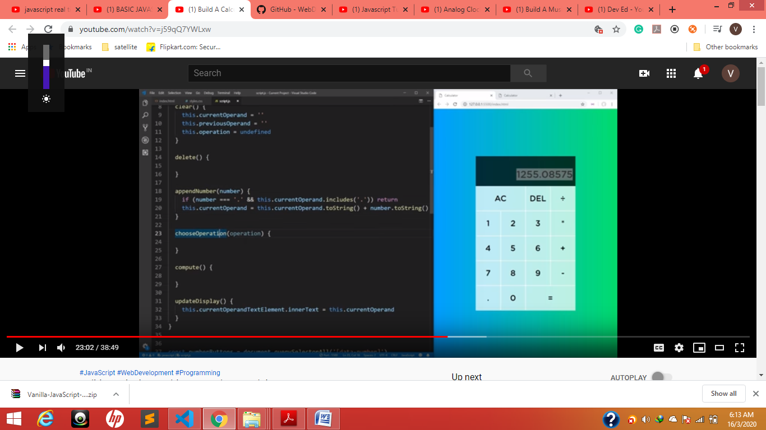

19-20 allows only once .

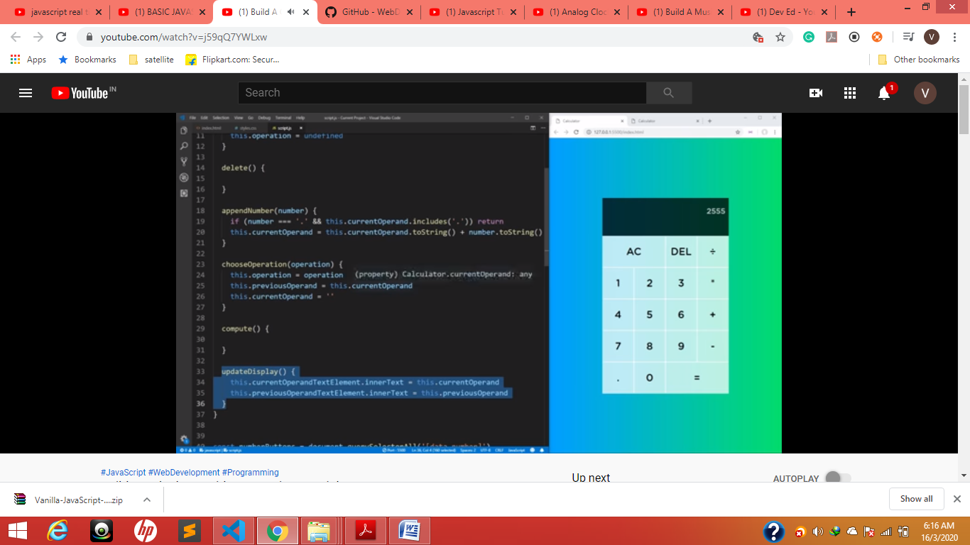

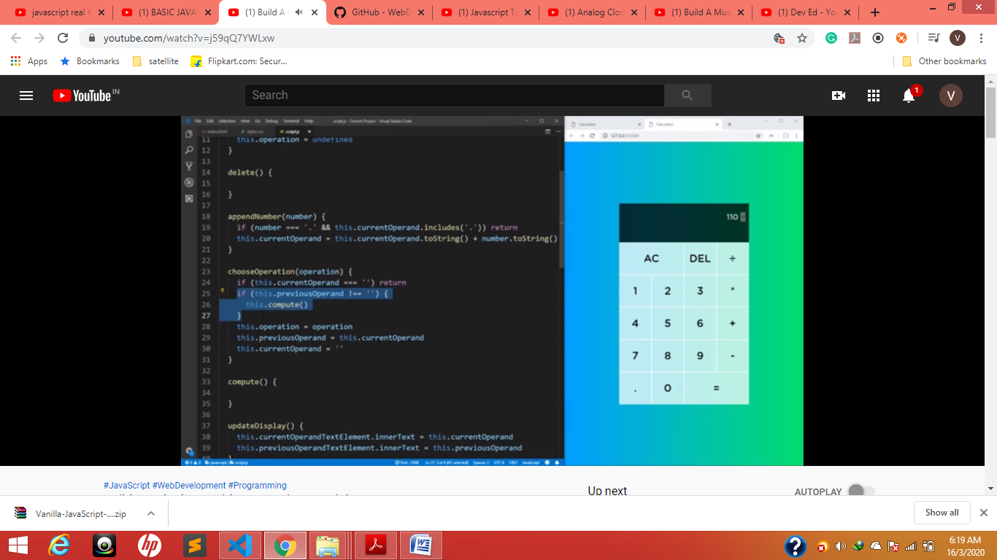

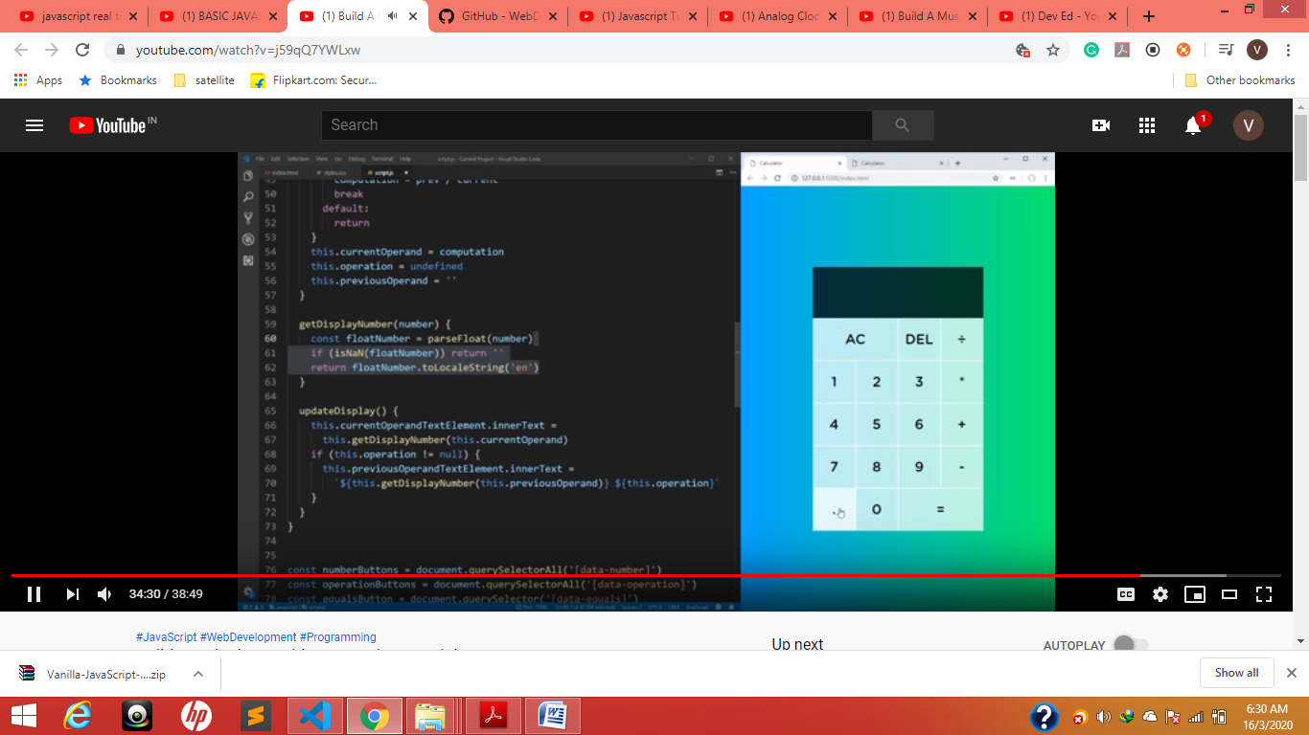

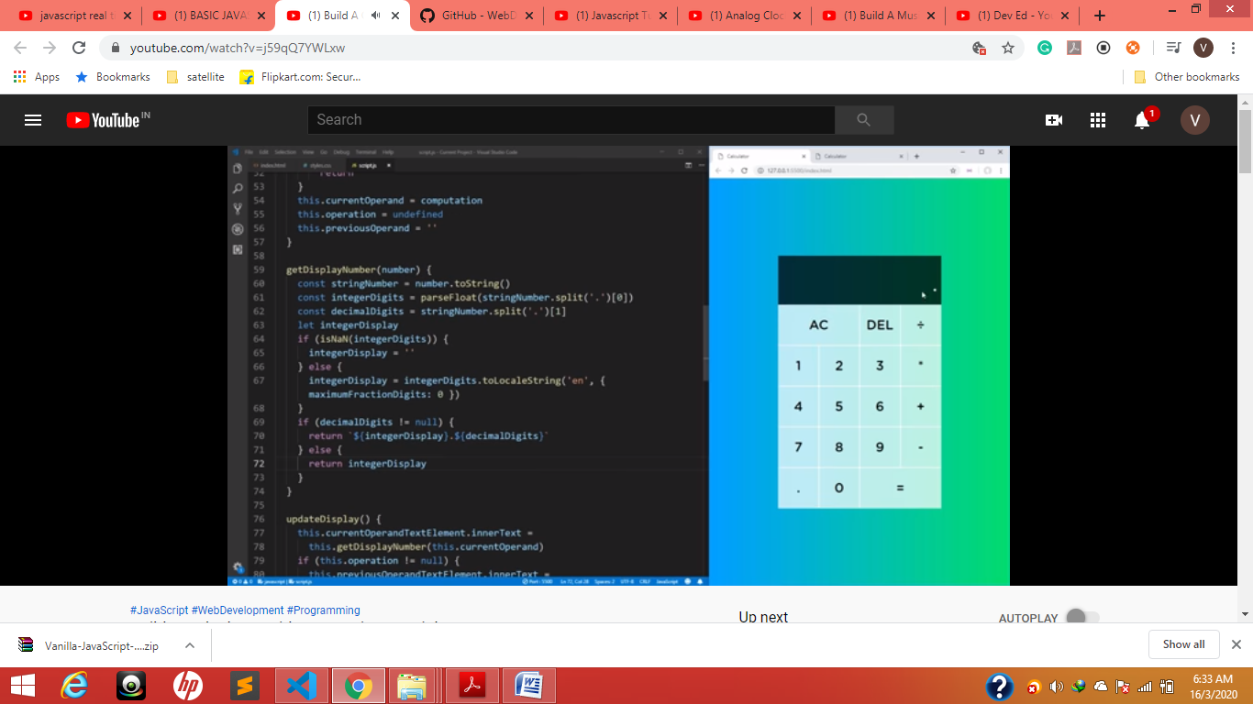

Es-15

Data.currently.temperature

Currently : { temperature :37.5, summary:”fully cloudy” }

Const { temperature }= data.currently

**Const { temperature, summary }= data.currently**

**Temperature = temperature or data.currently.temperature**

**Summary = summary or data.currently.summary**

.replace(/-/g, “_”) .toUpperCase()------🡪 all – will replace with _ and all characters into upper Case

**Examples**

Using the Set object

let mySet = new Set()

mySet.add(1) // Set [ 1 ]

mySet.add(5) // Set [ 1, 5 ]

mySet.add(5) // Set [ 1, 5 ]

mySet.add('some text') // Set [ 1, 5, 'some text' ]

let o = {a: 1, b: 2}

mySet.add(o)

mySet.add({a: 1, b: 2}) // o is referencing a different object, so this is okay

mySet.has(1) // true

mySet.has(3) // false, since 3 has not been added to the set

mySet.has(5) // true

mySet.has(Math.sqrt(25)) // true

mySet.has('Some Text'.toLowerCase()) // true

mySet.has(o) // true

mySet.size // 5

mySet.delete(5) // removes 5 from the set

mySet.has(5) // false, 5 has been removed

mySet.size // 4, since we just removed one value

console.log(mySet)

// logs Set(4) [ 1, "some text", {…}, {…} ] in Firefox

// logs Set(4) { 1, "some text", {…}, {…} } in Chrome

const language = {

set current(name) {

this.log.push(name);

},

log: []

}

language.current = 'EN';

console.log(language.log); // ['EN']

language.current = 'FA';

console.log(language.log); // ['EN', 'FA']

<https://www.youtube.com/watch?v=wPElVpR1rwA&list=PLhAYqyL8bdjy10dbfKoxnO4CXyGR9quCs&index=2>

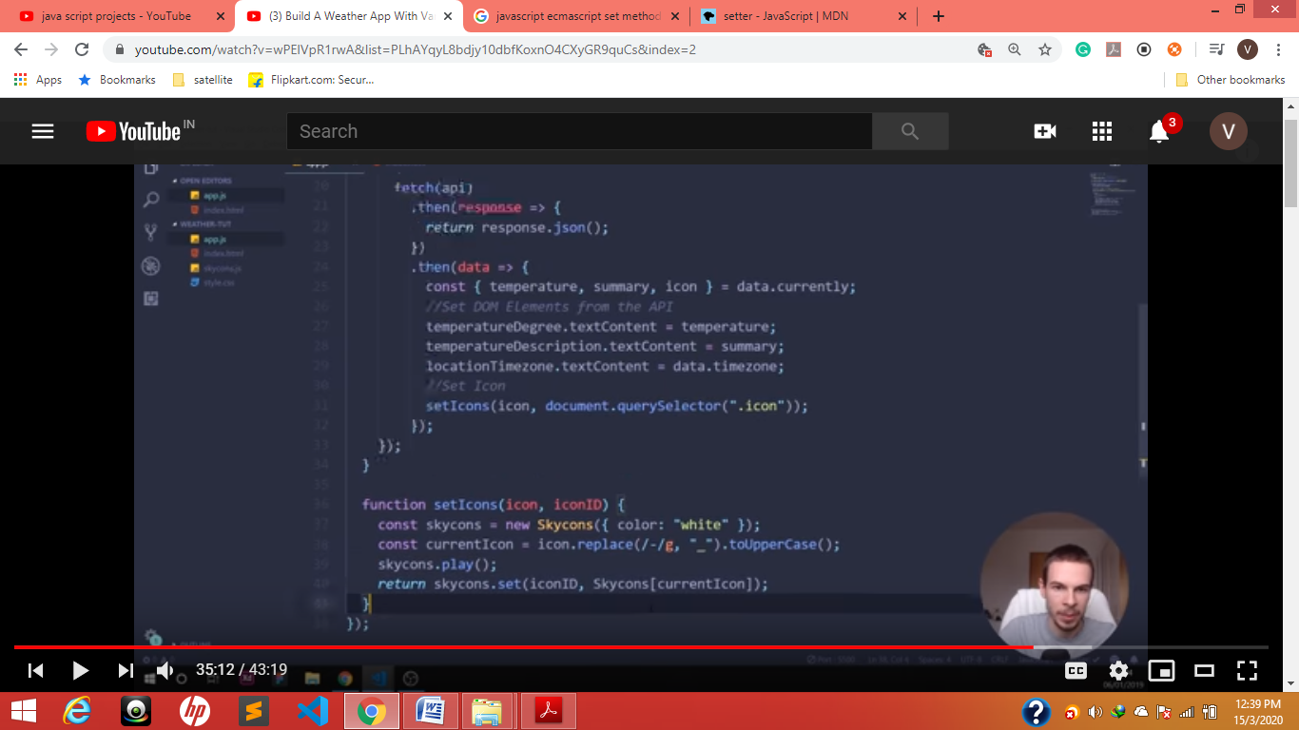

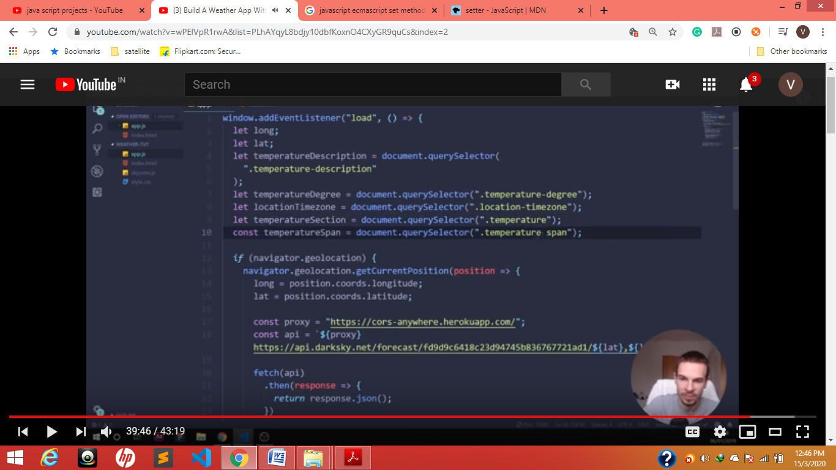

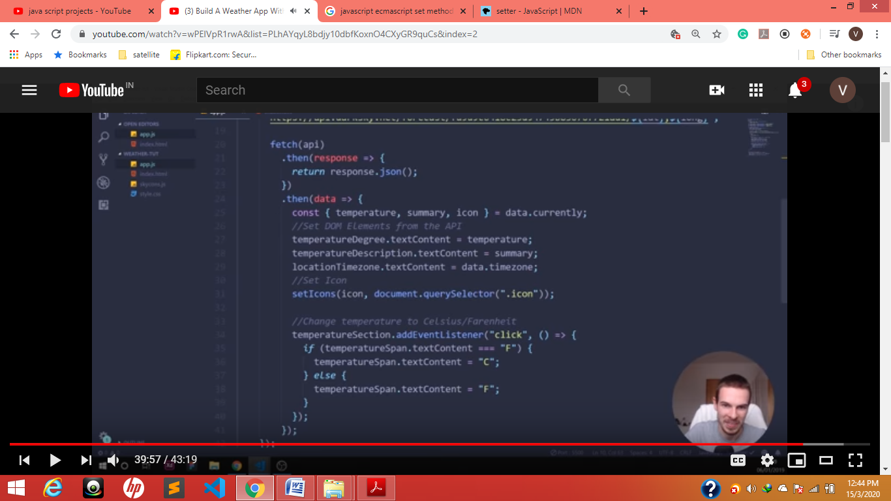

It will taggle 34—40

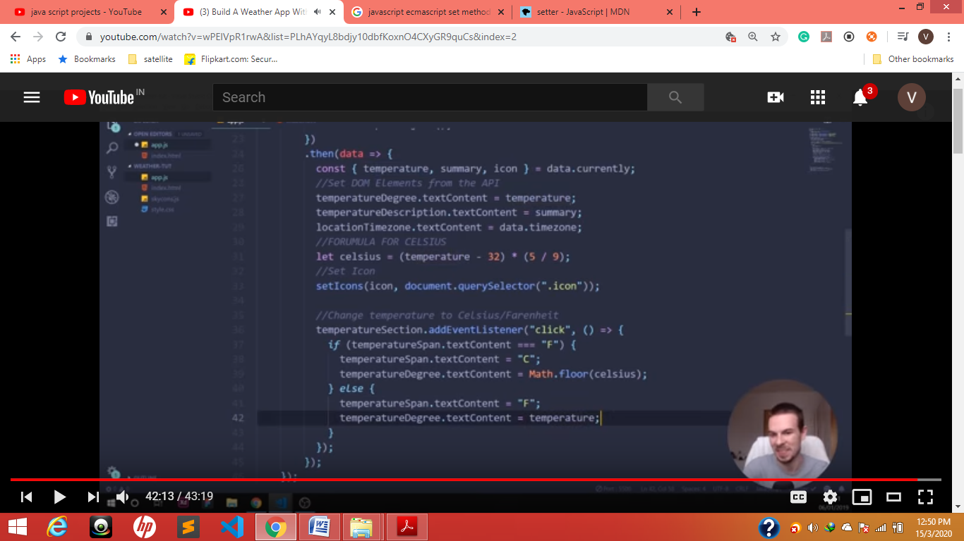

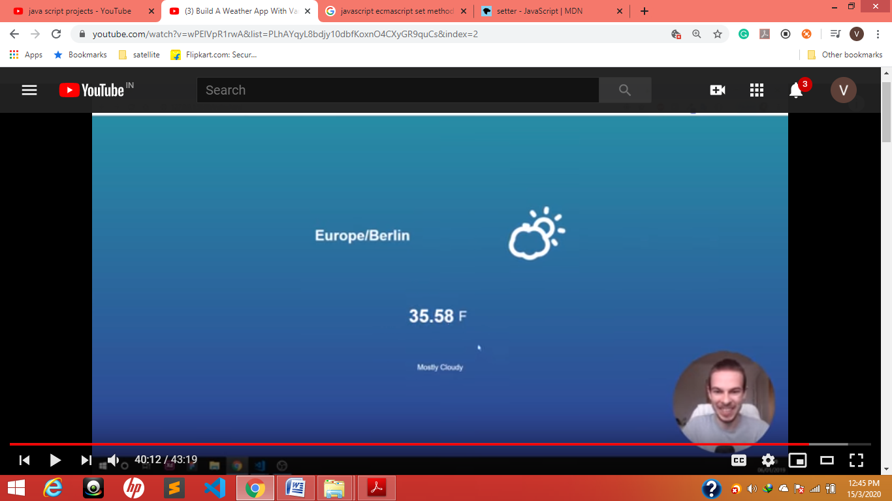

Snake game

<https://www.youtube.com/watch?v=9TcU2C1AACw&list=PLMVdlCX4rLgb61kIsa2_FfLkS3TYP65fW>

const ground = new Image();

ground.src = "img/ground.png";

let up = new Audio();

up.src = “audio/up.mp3 “

let audioName=new Audio()

audioName.play();

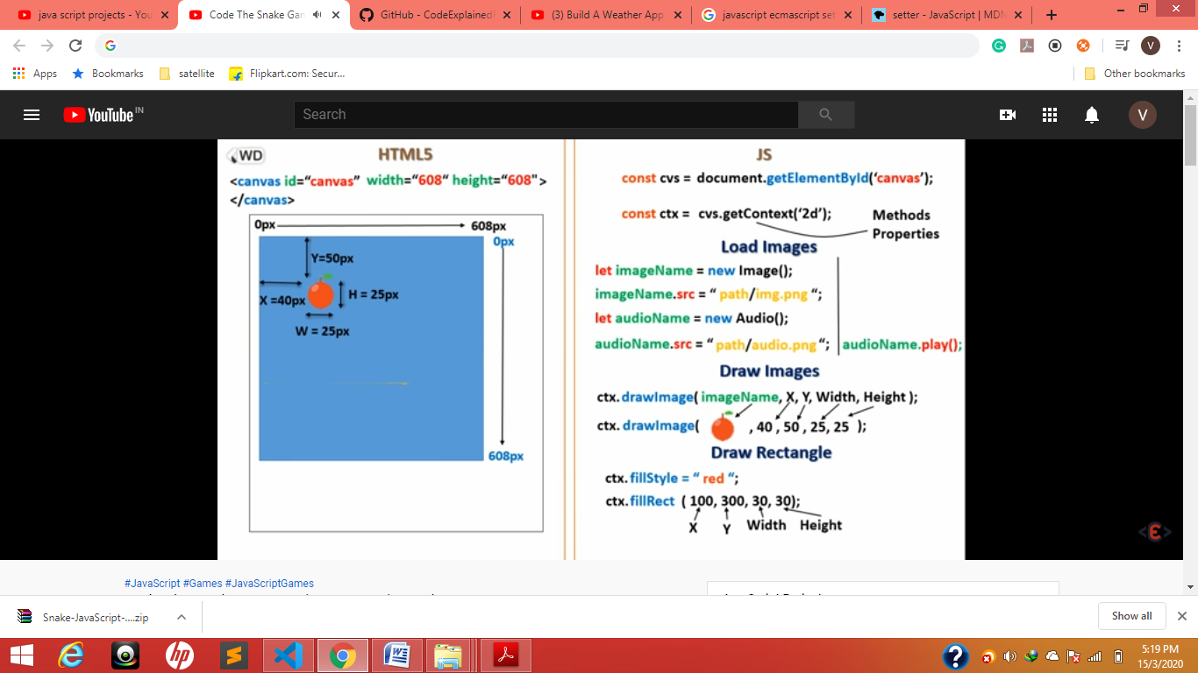

To draw images fruit and rectangle

